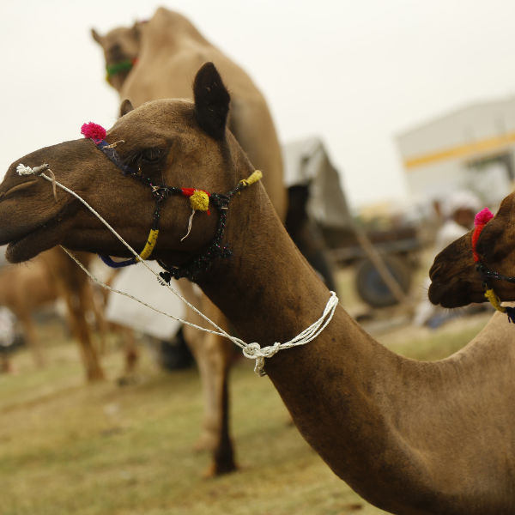
P5.S1.T1 Tips to organize trade fairs
A fair is an economic, social or cultural event and may take place at a fixed location or be held on a mobile basis. Fairs are usually dedicated to a specific theme or have a common purpose.
Specifically, in the world of events, we refer to "fairs" when we talk about facilities where products of a single commercial or industrial sector are exhibited for promotion and sale, such as "Promoting the products of one region" or "Crafts".

Fair can be a great opportunity for small farmers to have access to procurers like wholesalers, new customers, and retailers. The linkage can be extended to export markets too.

These dynamics between buyers and sellers make the fair a meeting place, were exchanging experiences and information is sometimes more important than buying and selling the product.

The advantages of trade fairs:
- They are a meeting point between supply and demand that facilitates business. It is a perfect way to get in touch with your target public and with wholesalers and suppliers.
- The contact with customers is direct and personalized. The attendees to the fairs are people already interested in the specific topic and are usually willing to see offers and buy.
- For vendors, trade fairs are a means of making their products or services known, observing the competition, testing or launching products, finding distributors and making sales.
- The cost per sales contact at a trade fair is unquestionably the lowest: in just a few days you can sell a lot to many, even to the most difficult customers.
Many vendors make a large percentage of their annual sales only at trade fairs. Below are the main characteristics of these types of events, one of the most celebrated nowadays in many countries.

Organizational elements of trade fairs
The organisation of trade fairs, either because of their complexity or their specificity, has some elements that differentiate it from the organisation of other events. As organizers of the event, we will be responsible for establishing order and sequence of the tasks that will ensure the success of the event. This is achieved by developing a plan that contemplates all the activities, from the informal ones such as assembling and dissembling of the vendors, to the formal ones such as the inauguration and attention to guests; also including the application of controls during the event, planning for unforeseen events and security measures.

A fair should be prepared for months, usually lasts several days and is often recurring.

Choice of Venue.
Choosing the venue is one of the first factors to consider when organizing these events. It involves not only the choice of the place where the event will take place, but also:
- Its location
- Accessibility
- Parking
- Security
- Natural and artificial lighting
- Decoration
- Sound and ambience
- The design concept of the physical exhibition space
The typical layout of a trade fair consists of the organization of the exhibition space into large areas, which in turn are divided into smaller units called stands. Booth sizes may vary according to the needs and budget of each vendor. In order to market the space at a trade fair, the most common thing to do is to design a floor plan with the distribution of the modules of a standard size (2x2 / 3x2 / etc.). When closing the agreement, the vendor/productive cooperative must receive a contract with a plan showing the location of the stand within the exhibition as a whole, as well as an individual plan of each stand.

Date and duration.
In order to choose the date and duration, aspects such as the availability of the chosen venue and the coincidence with other similar events, which may distract the attention of the target public, should be taken into account.
The duration is also closely linked to the planning of the objectives of the exhibition and the number of people expected to attend.
Another factor that usually affects the duration is the periodicity of the fair and how long they have been held. Well-established fairs, with 20 or more editions, usually last between 3 and 5 days.

Publicity and promotion.
This is one of the most important tasks in the process of organizing the fair. The promotion of the event is essential to ensure its success. The development of an advertising campaign, accompanied by an adequate media strategy, is key to meeting the exhibition's communication objectives with the previously defined target public, with a view to capturing their attention and promoting their attendance.

Evaluation
Lastly, it is recommended to evaluate the outcome of the fair, both the organization itself: whether the publicity was appropriate, the target public, the date(s) and length, the place chosen to hold the fair, the budget, etc., as well as the impact it has had on the merchants (i.e. whether they have sold their products, made contacts with clients, with other producers, etc.). The evaluation allows for learning and correcting possible mistakes for future editions on the one hand, and on the other hand, allows producers to assess the success of their business.

