Tool P1.S2.c.T1 Field work preparedness tool
Area of intervention:
Develop a plan for each area of intervention
Date/s:

Together with the project team and/or with the help of local branches in the target area, identify the following information for each area of study:
- communities/localities or neighbourhoods/cities in the target area (population, distance),
- markets (frequency, type, accessibility) or commercial areas, and
- key actors present in the assessment area.

The localities, communities/neighbourhoods to visit. It is not normally possible to visit all the localities in the designated target area. In this sense, criteria should be established to choose a representative sample such as: accessibility/proximity to markets, population size, livelihood areas, etc. choosing at least one of each type (near / far from markets, small and large communities/neighbourhoods, etc.).
Location | Population | Distance (to main location) |  | Other relevant information
Key markets to visit. The team should check what they are key markets and commercial areas (depending on the context) for target locations as well as for potential products/services, and it is necessary to visit as many as possible and at the time when there is more exchange of products, and if possible visit at different times of the day (morning, midday and evening). In some countries, market accessibility for women may not be possible and an alternative market may exist. If so, you should also visit this market.

Market name | Location | Type of market |  | Frequency
Key and main actors. Depending on the context, some actors are more relevant than others. Since there is no time to interview everyone, the team must agree who could be more interesting to talk to. It is appropriate to interview technicians with field experience.
Actor | Location | Availability |  | Other relevant information
If necessary, especially if part of the field team did not participate in the development of the tools or in the initial phase, include a session in the schedule training that contains:
- the objectives of the assessment and the process (steps)
- the use of tools
- tool test

Adjustment and correction of final tools based on test feedback!

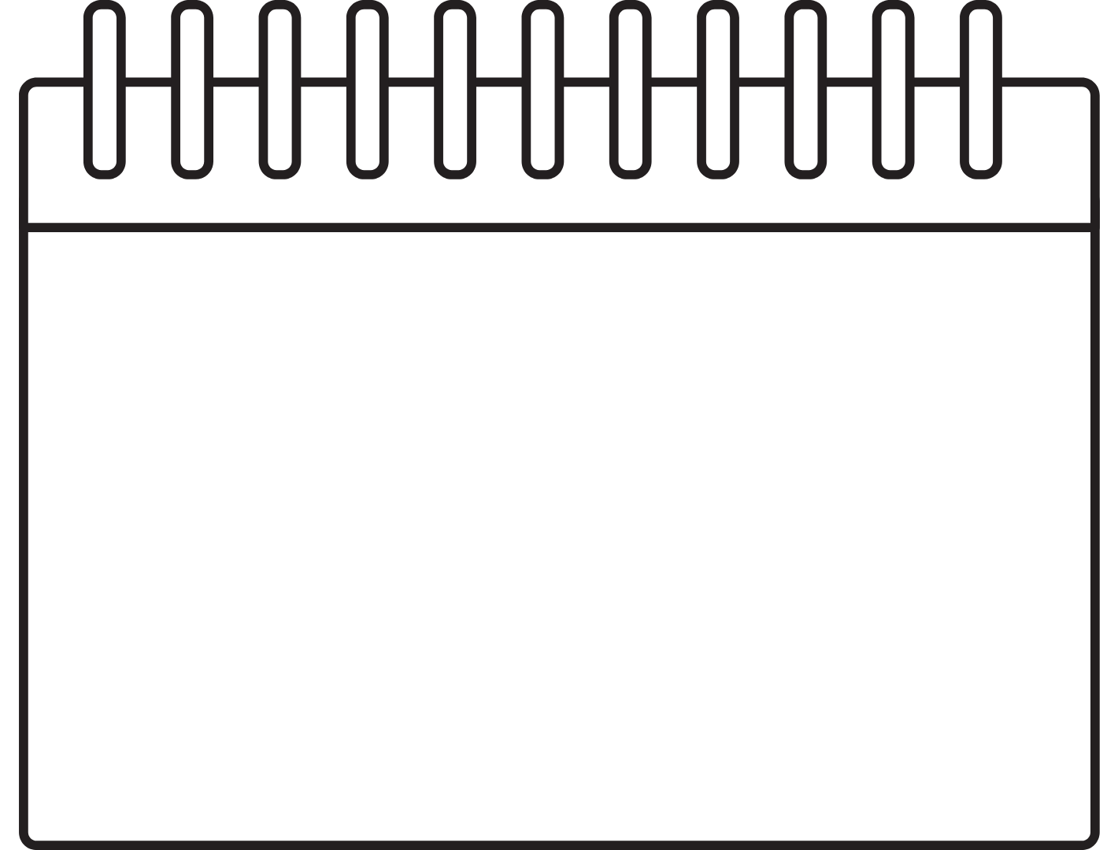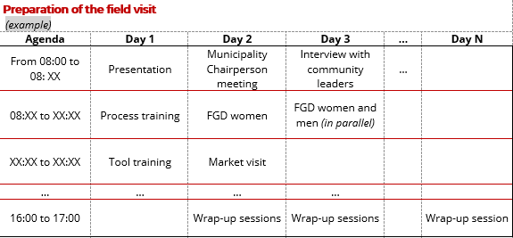
Other recommendations:
- Include wrap-up sessions (debriefing) at the end of the day (or at the beginning of the next day) in order to share the main lessons learned from the day's visit, changes in planning or review of tools.
- For surveys, calculate the sample needed for the data to be extrapolated / valid for the analysis.
- During the focus group planning it is necessary, among other aspects, to divide the groups between men and women, target group/s, etc.
- Adjust planning (duration, number of towns/actors to visit, etc.) to available resources (people, vehicles, etc.).
- Test the tools and revise them if necessary after testing before starting with the visits.

