DATA SHEET: HABBANAYÉ

CONTEXT
Within the framework of the project ................................................................................................................................., one of the activities planned is the replenishment of the livestock population by granting ............................... to ............................... according to a traditional Fulani practice commonly known as ‘Habbanayé’.

DEFINITION
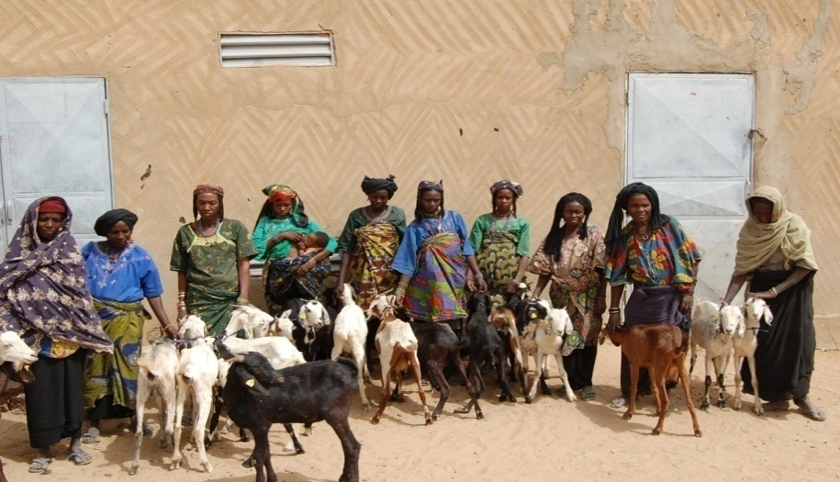
‘Habbanayé’ is an ancient practice of livestock farmers which is in effect a system of social solidarity and consists of assisting an impoverished livestock farmer to replenish his herd.
This assistance takes the form of supplying breeding stock, which the recipient then rears for an agreed period (after a few pregnancies) and returns to the owner, keeping the offspring.

OBJECTIVE
The objective of ‘Habbanayé’ is to improve the living conditions of agro-pastoral households severely affected by climate risks, by reducing their vulnerability to food insecurity.

METHODOLOGY / IMPLEMENTATION STRATEGY
The approach adopted for the implementation of this ‘Habbanayé’ strategy is as follows:
- Selection of organised, dynamic and socially cohesive farmers' organisations (FOs), preferably with accreditation.
- Promotion/awareness-raising regarding ways to implement the process.
- Selection of beneficiaries, based on household vulnerability criteria. <N> female/male beneficiaries per farmer organisation.
- Purchase and placement of animals by tender/purchasing committee.
- Receipt, vaccination and closure before implementation at FO level.
- Signing of contracts and granting to beneficiaries: translation of contracts into local language and explanation by technical services and project technicians.
- Content of contracts:
  - Rotation system (after 24 months).
  - Constitution and management of replacement funds (dues of XXX [currency] / month / head of livestock).
  - Veterinary care, animal care, etc.
  - Each beneficiary is given XX heads of livestock (e.g., 2 nanny goats and 1 billy goat) for the farmer’s organisation.
- Training of beneficiaries in association life, livestock husbandry and management.
- Monitoring of activity:
  - Community monitoring (municipality and FO office).
  - Technical monitoring (agricultural experts and livestock service agents).
  - Health monitoring (state or private veterinary service (agent), trained BIAZ - shops for agricultural and zootechnical inputs - managers).
- Evaluation of the activity: effects, impacts, etc.

